**Sorting**

* **Sorting Introduction:**

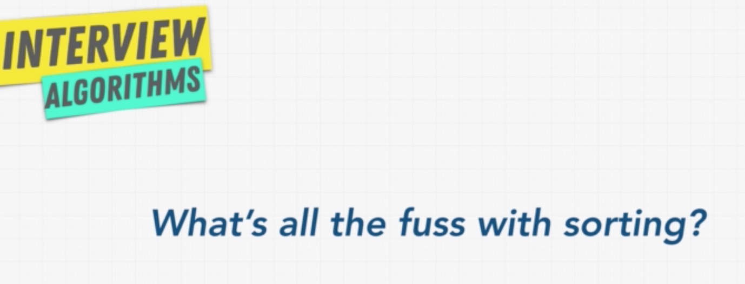

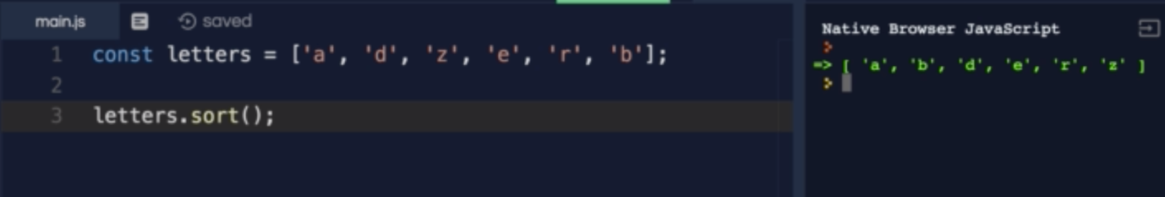

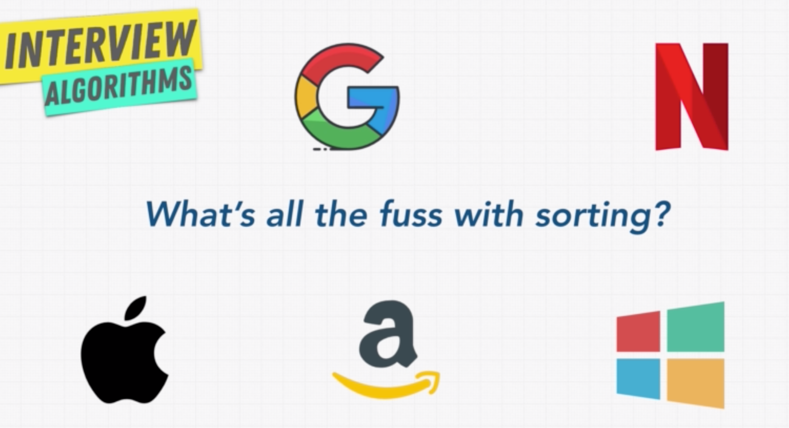

Sorting method which comes with the programming language won’t work efficiently for the companies given above, as they have to handle millions and millions of records.

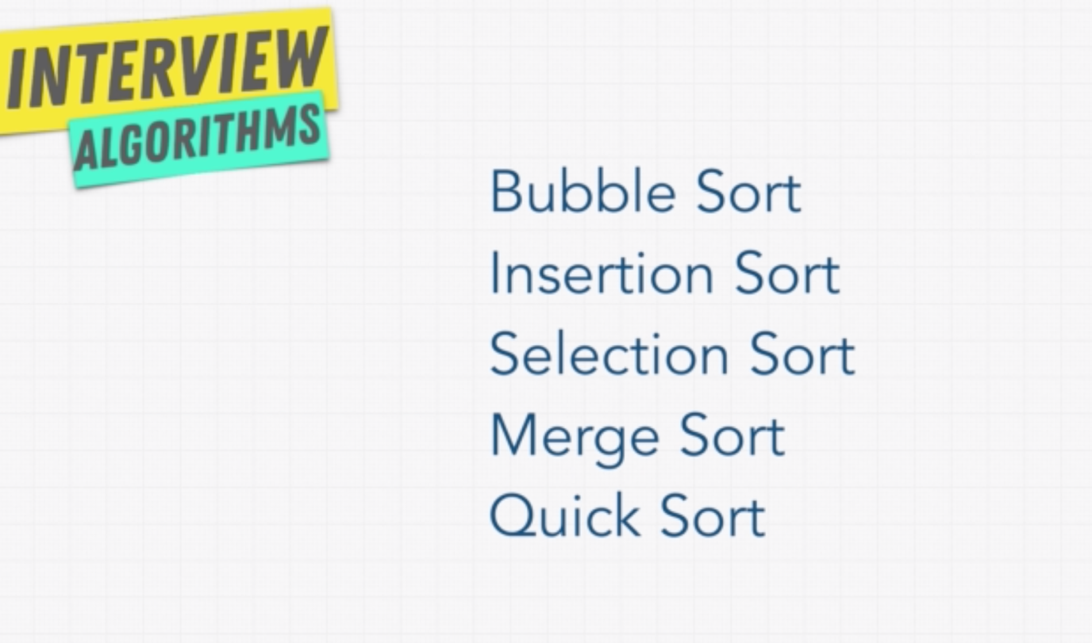

* **The Issue with sort():**

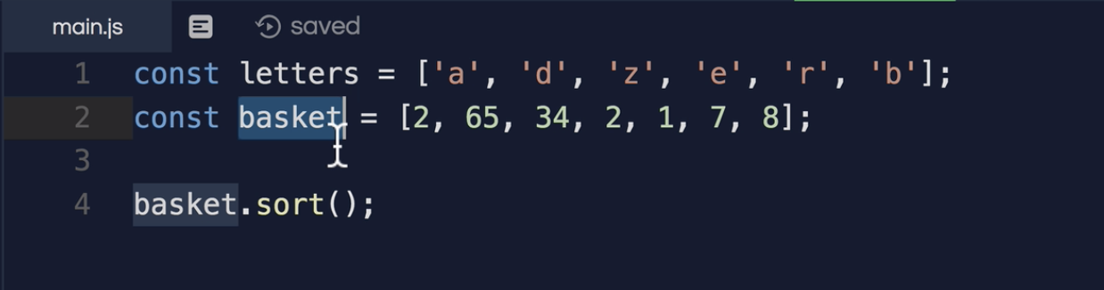

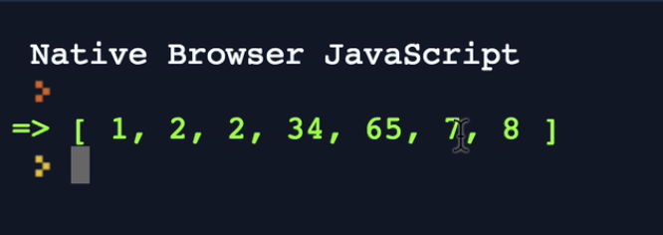

In Javascript, the sort method uses the Unicode value, so the results will not be as expected.

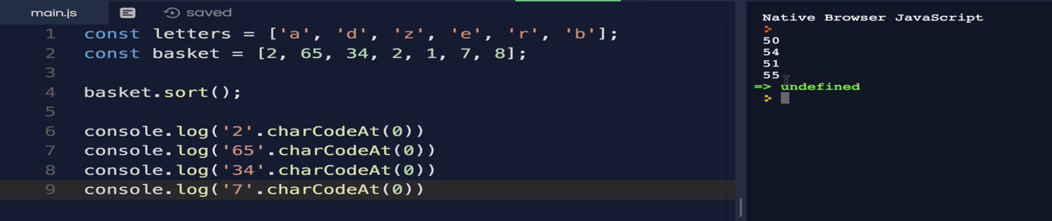

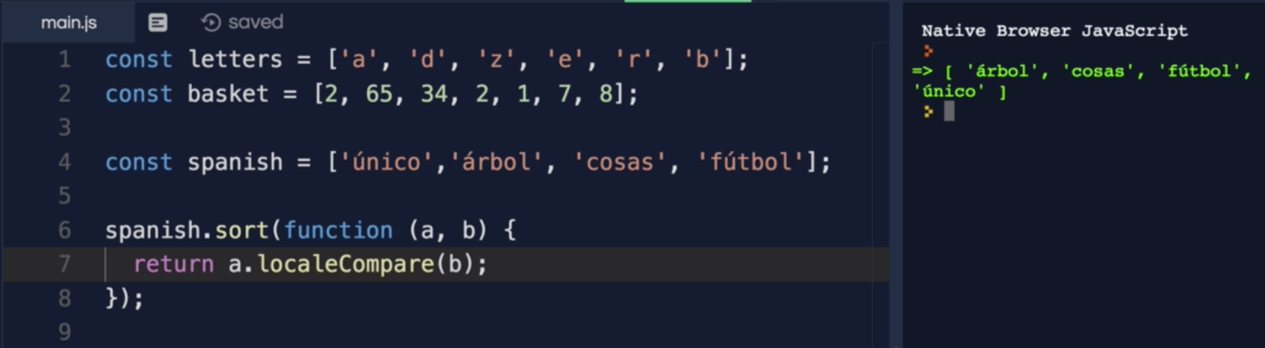

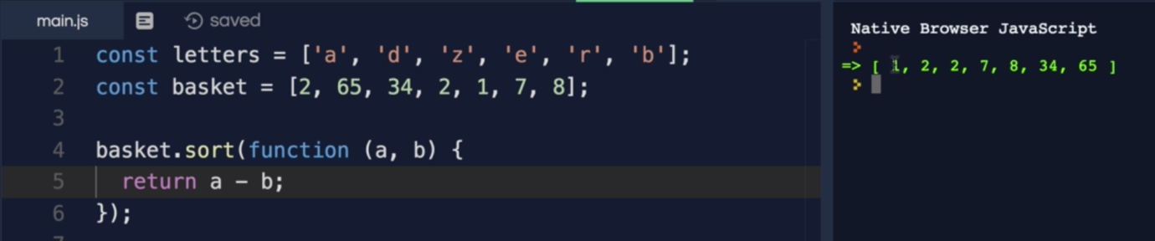

* **Sorting Algorithms:**

https://toptal.com/developers/sorting-algorithms

* **Bubble Sort:**

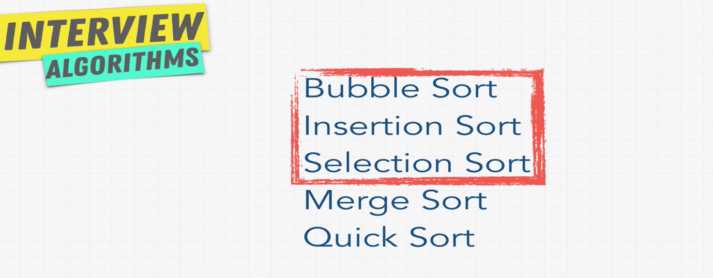

Bubble sort falls under elementary sort. They are very simple and basic algorithm.

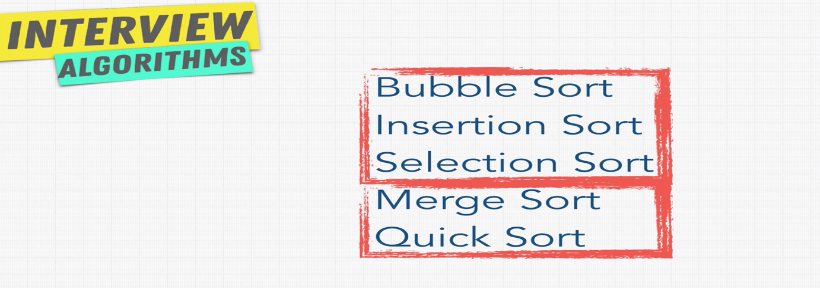

Merge and Quick sorts are complex one.

Bubble Sort:

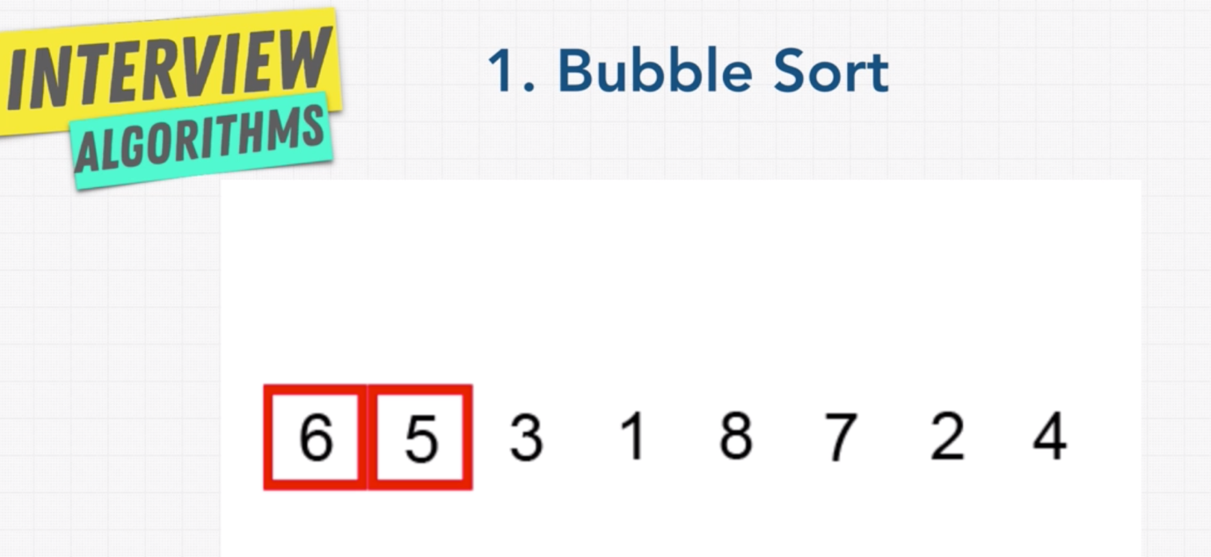

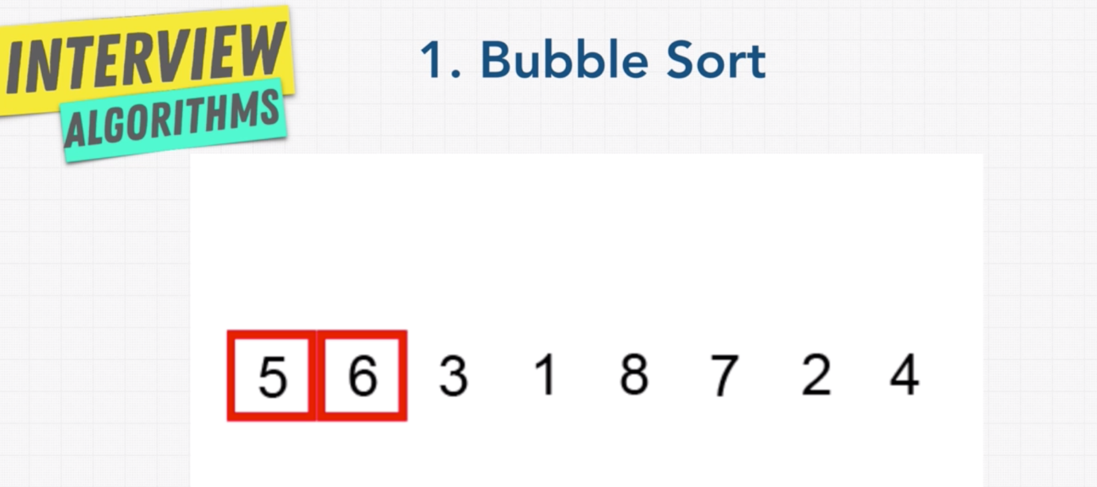

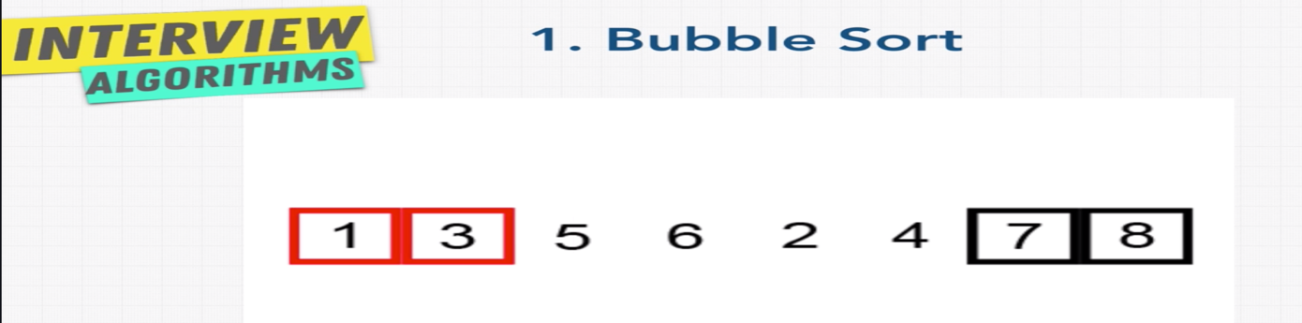

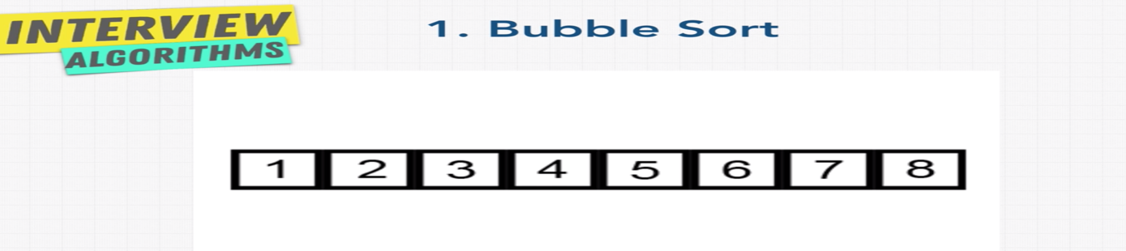

Bubble sort is one of the easy and least efficient algorithm.

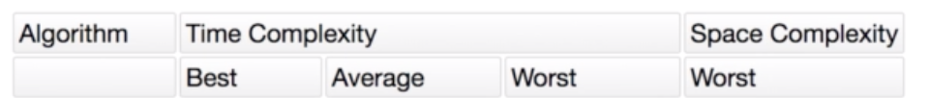



* **Solution: Bubble Sort:**

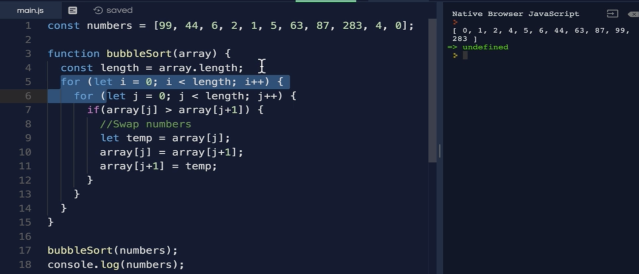

In bubble sort for each iteration, the bigger value bubble up to end of the array.

* **Selection Sort:**

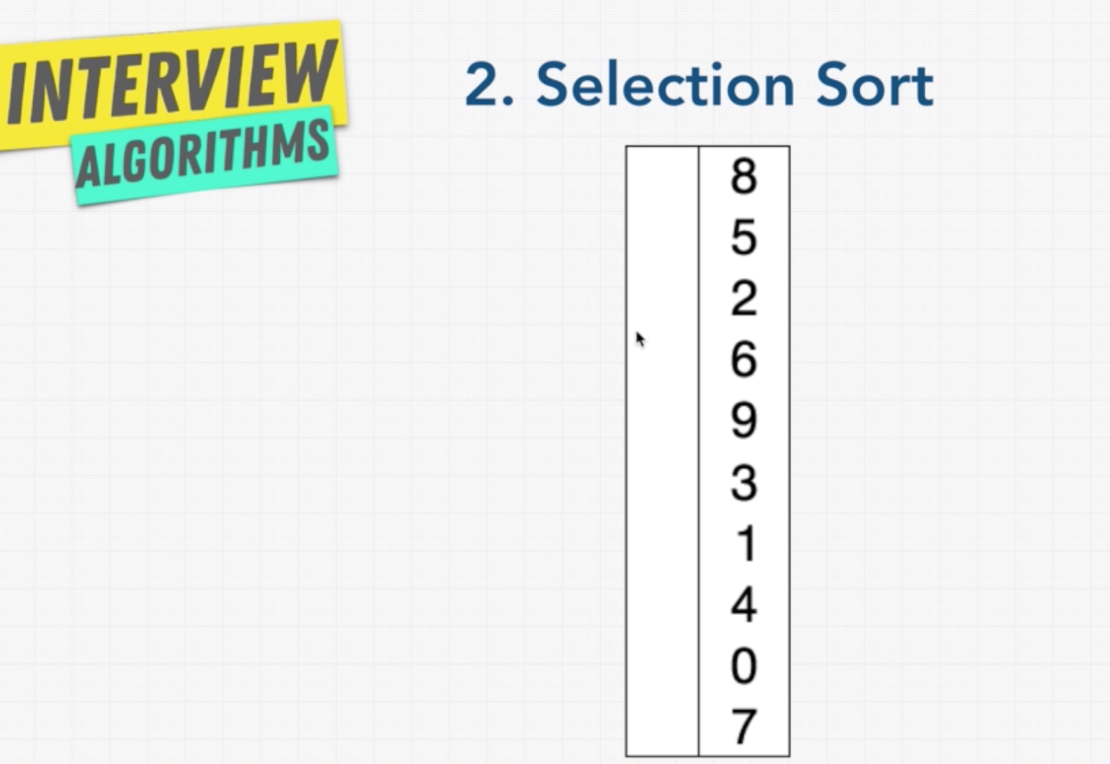

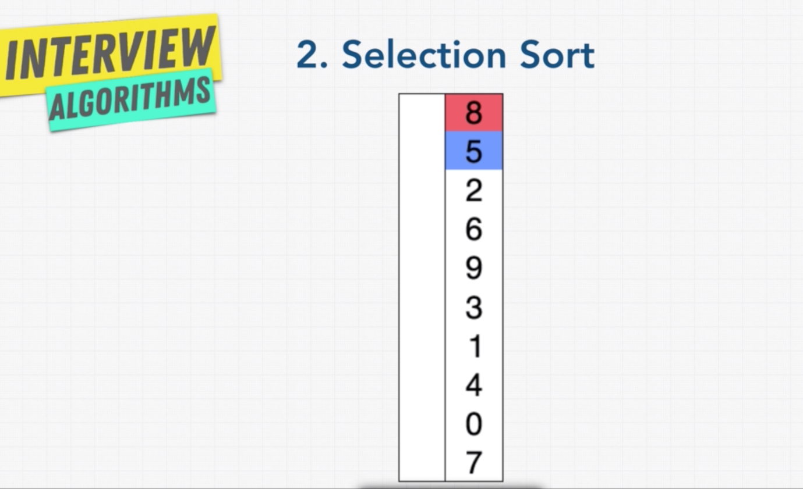



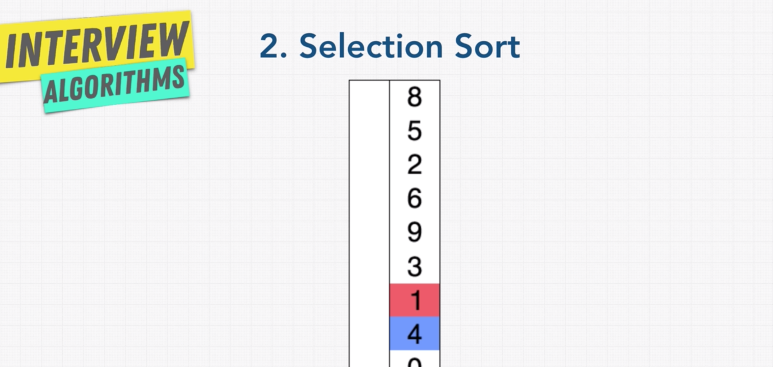

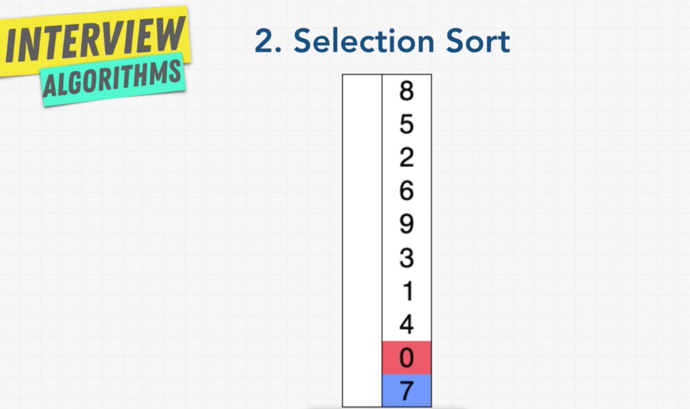

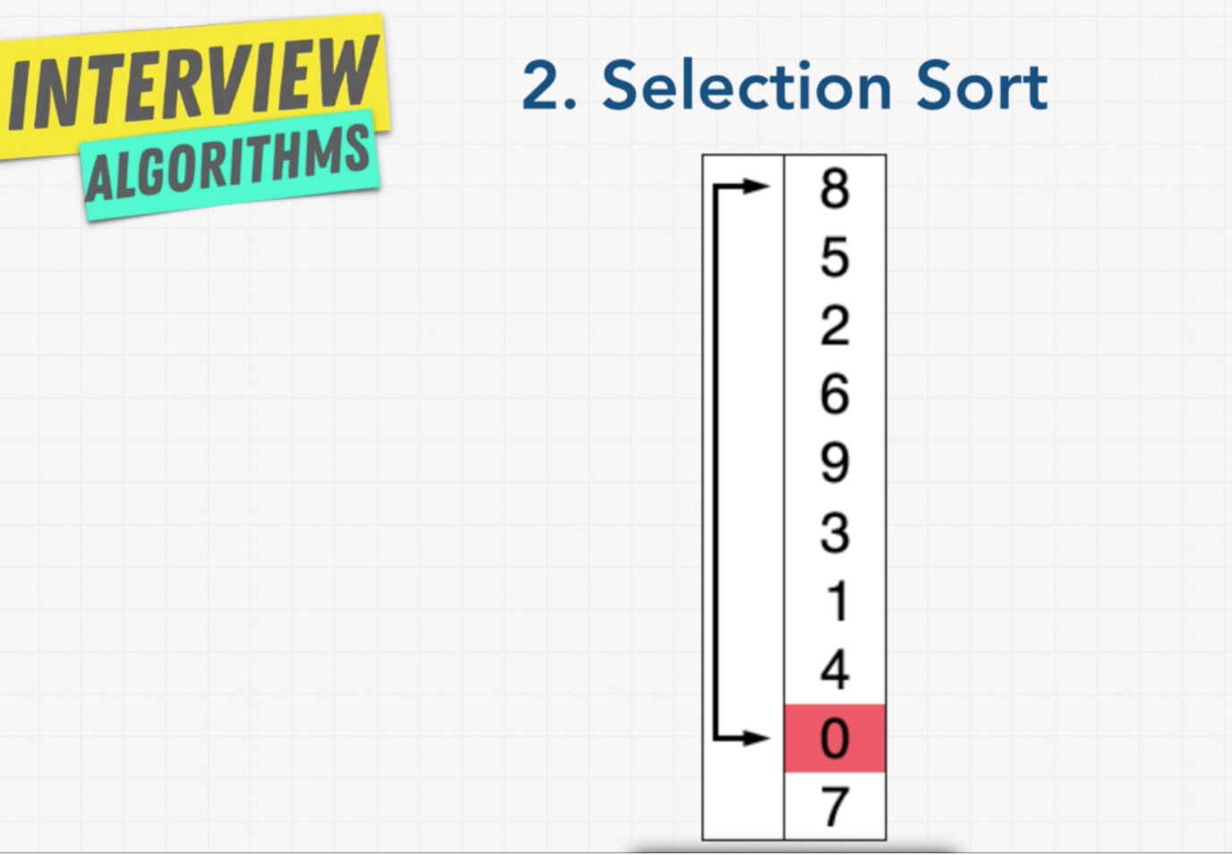

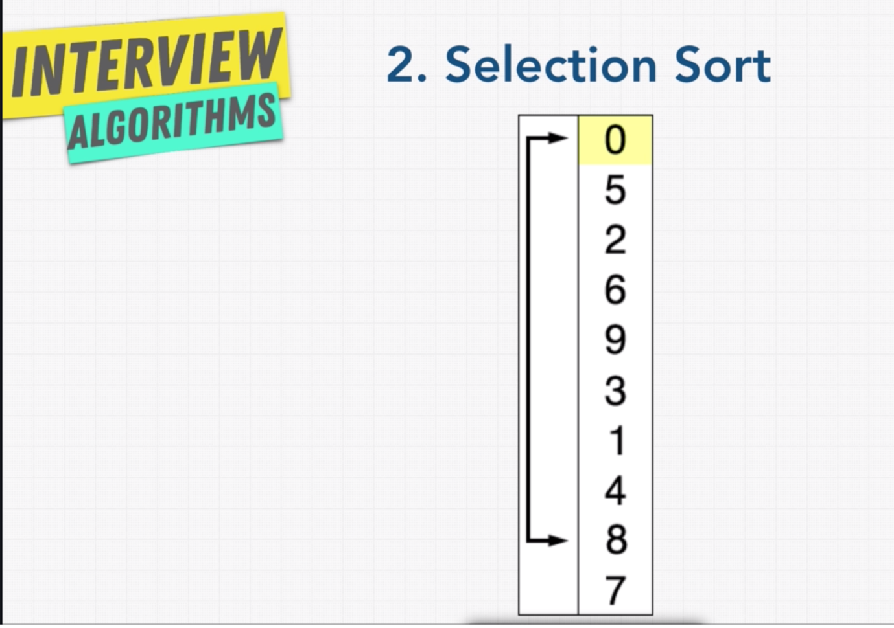

Like this the iteration will go until it completes all the elements.

* **Solution: Selection sort:**

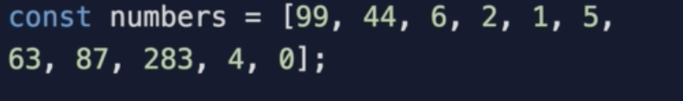

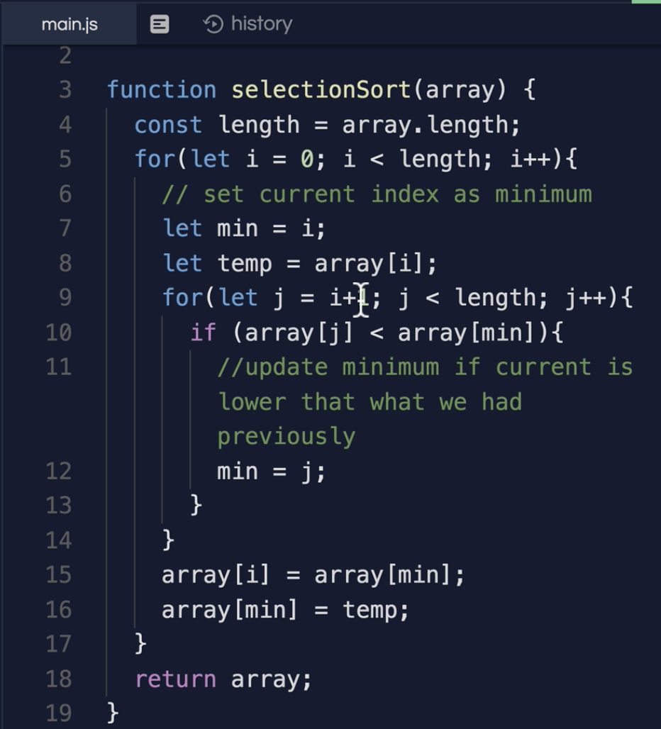





* **Dancing Algorithm:**

In youtube search for “***sorting algorithm dance***”, they explained all the sorting with real people dancing.

* **Insertion Sort:**

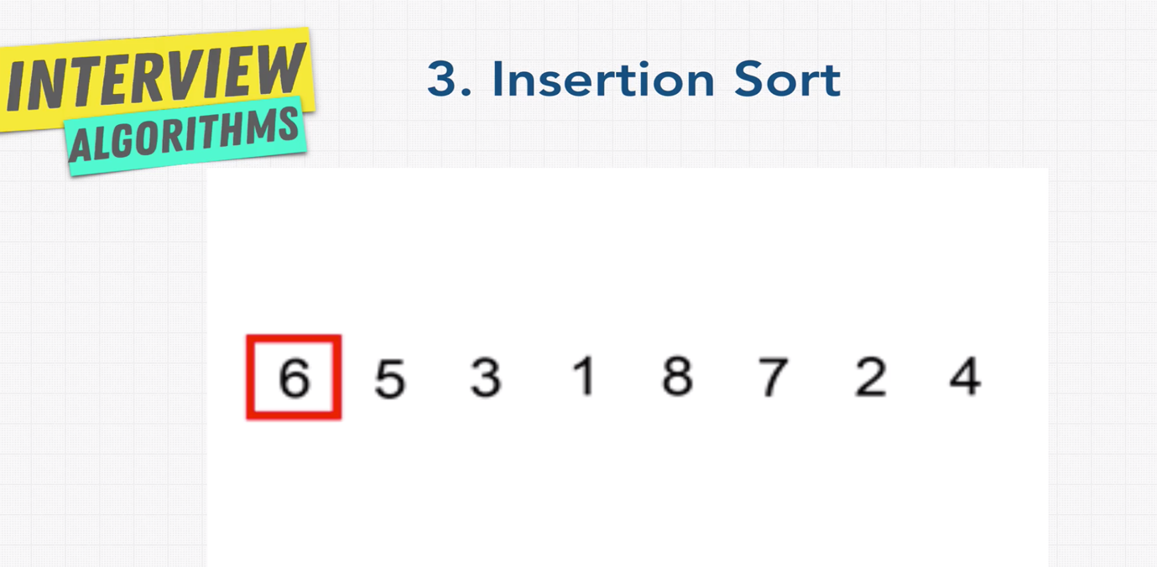

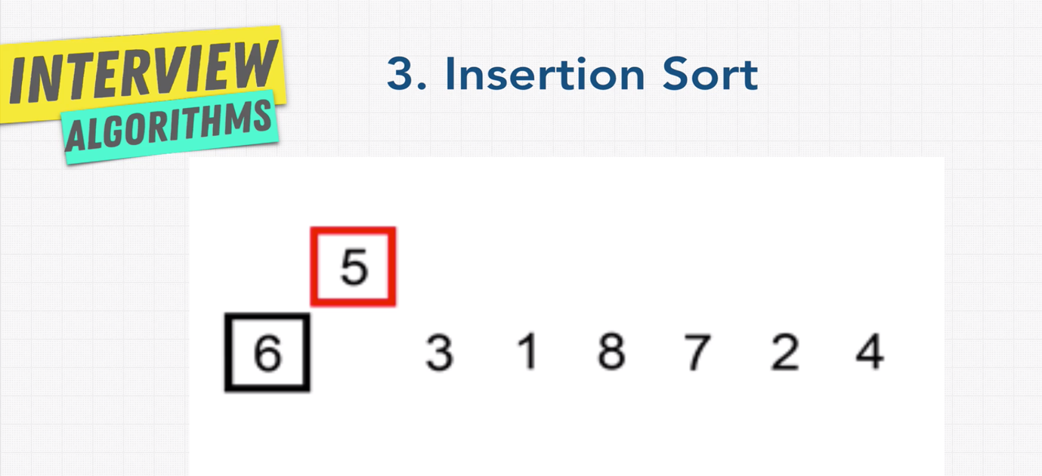

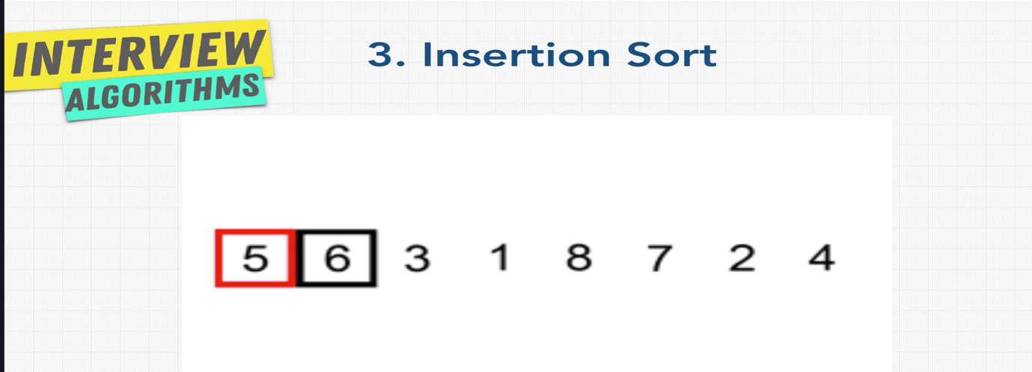

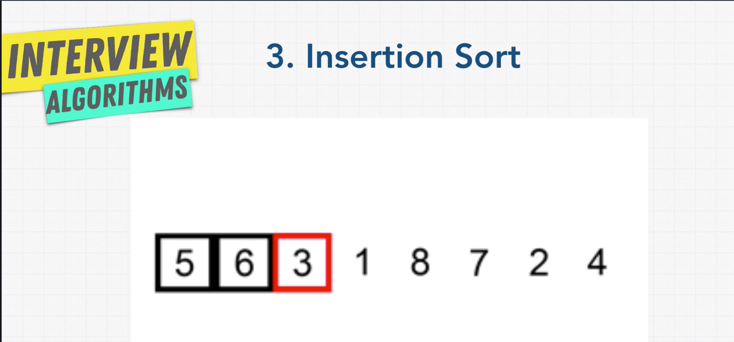

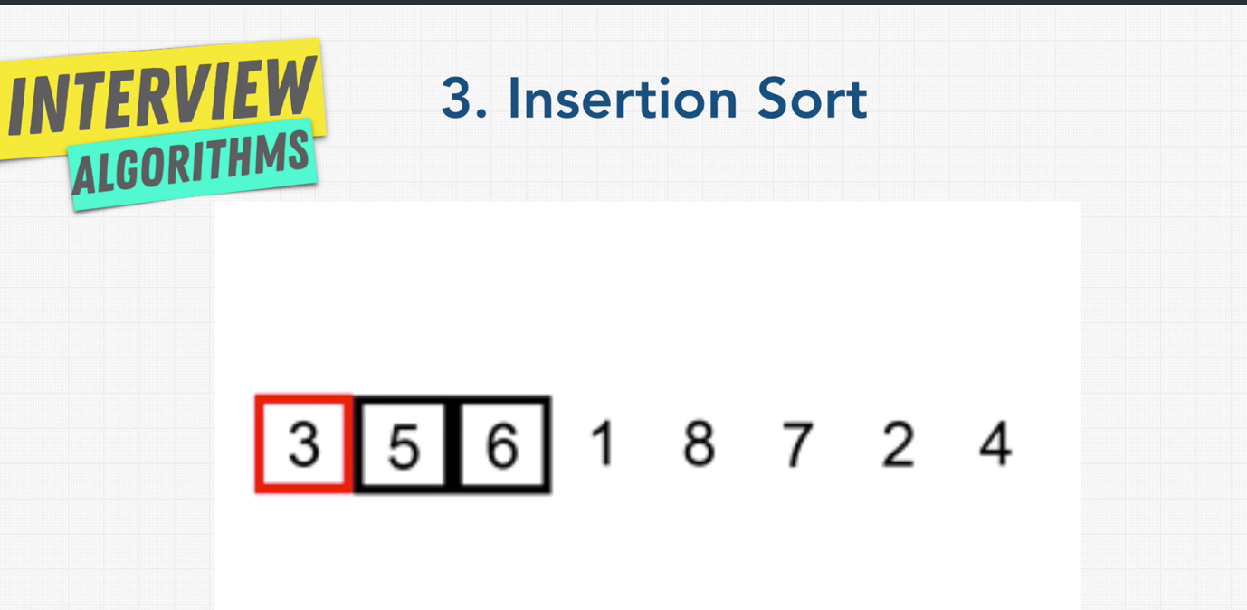

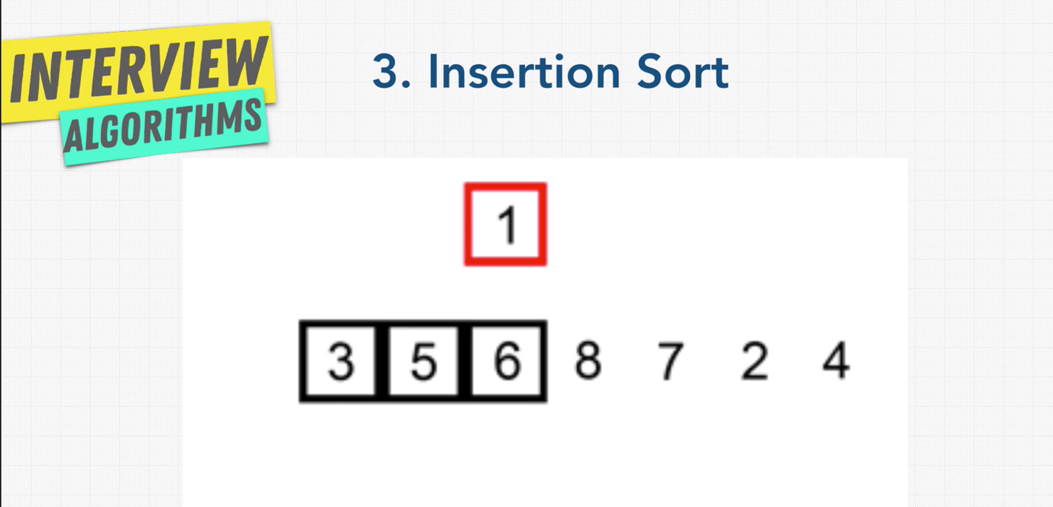

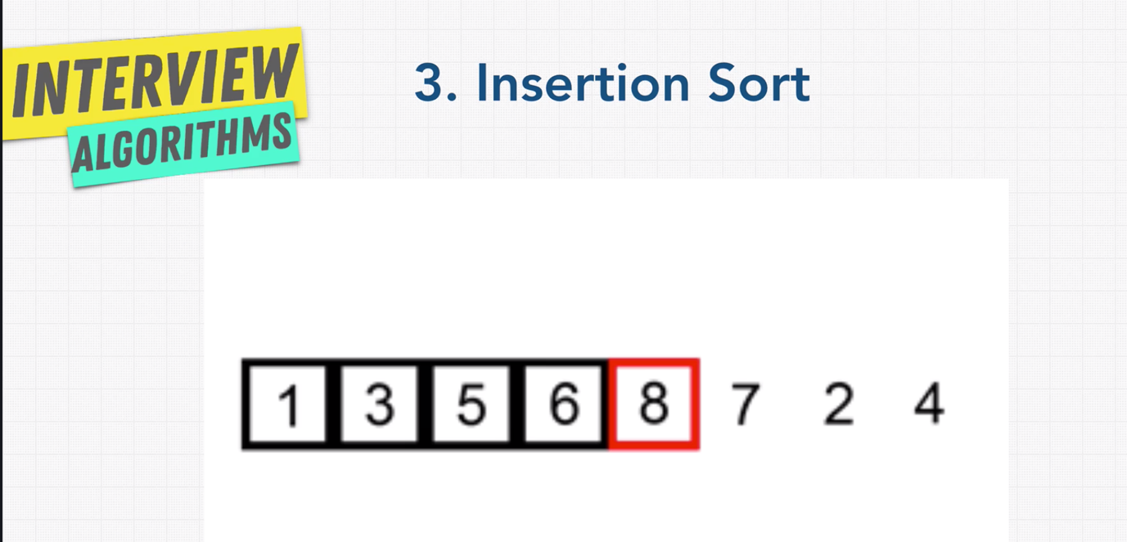

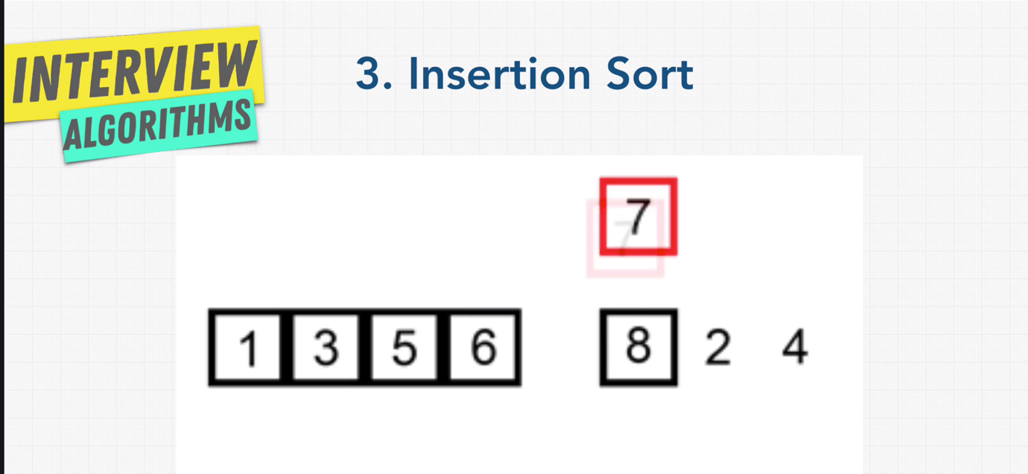

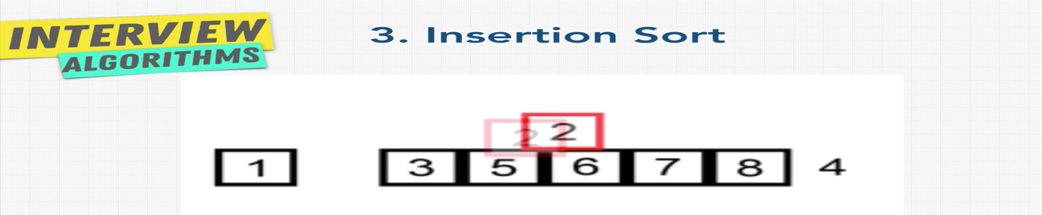

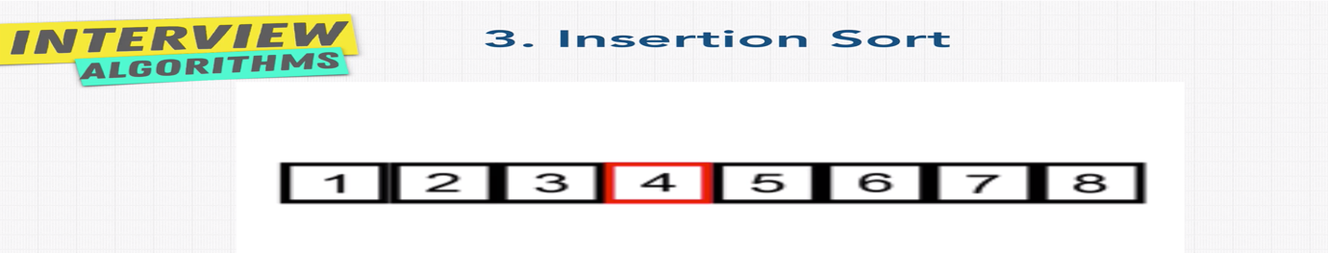

Note: Insertion sort is fast when the data set is small and the data set is nearly sorted.

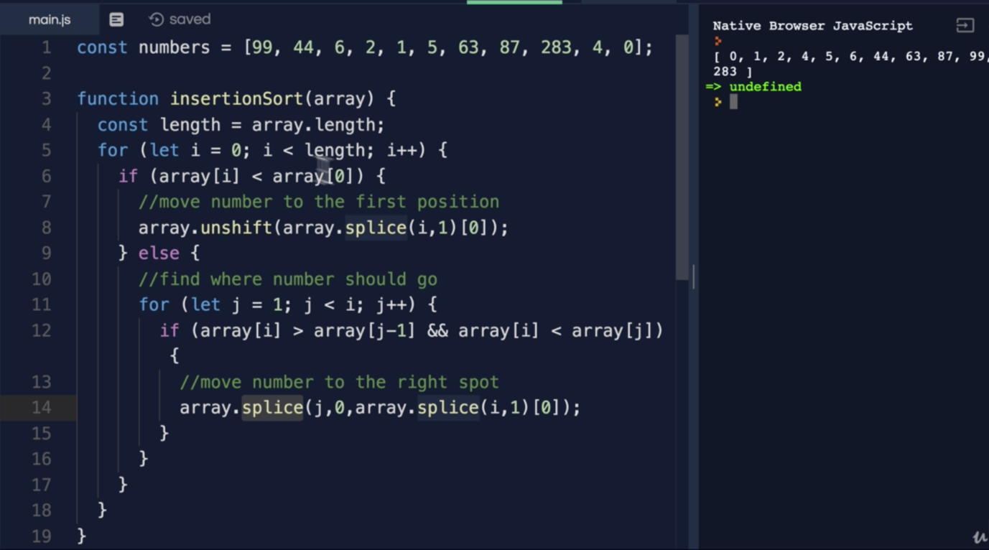





* **Merge Sort:**

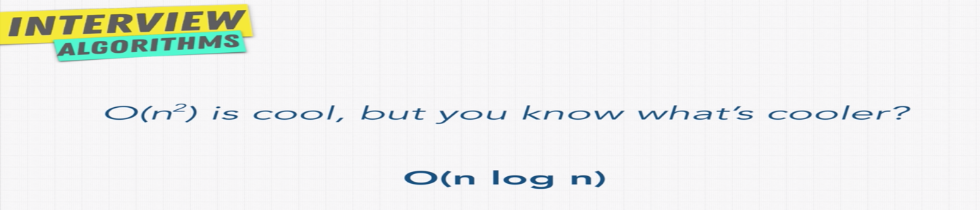

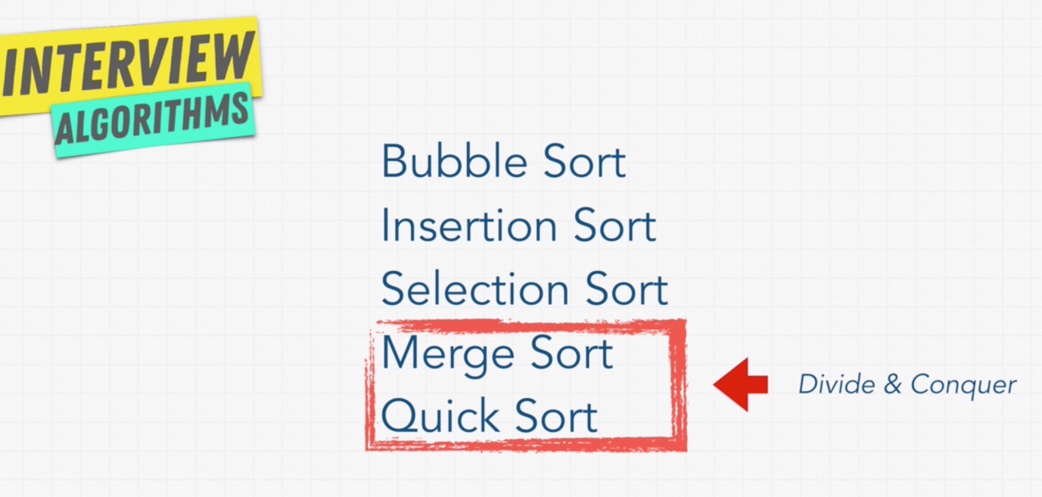

**Steps:**

